Physical Chemistry Seminar

**Tuesday, 11:00 am Room 1315**

##### March 13, 2018 Chemistry Building

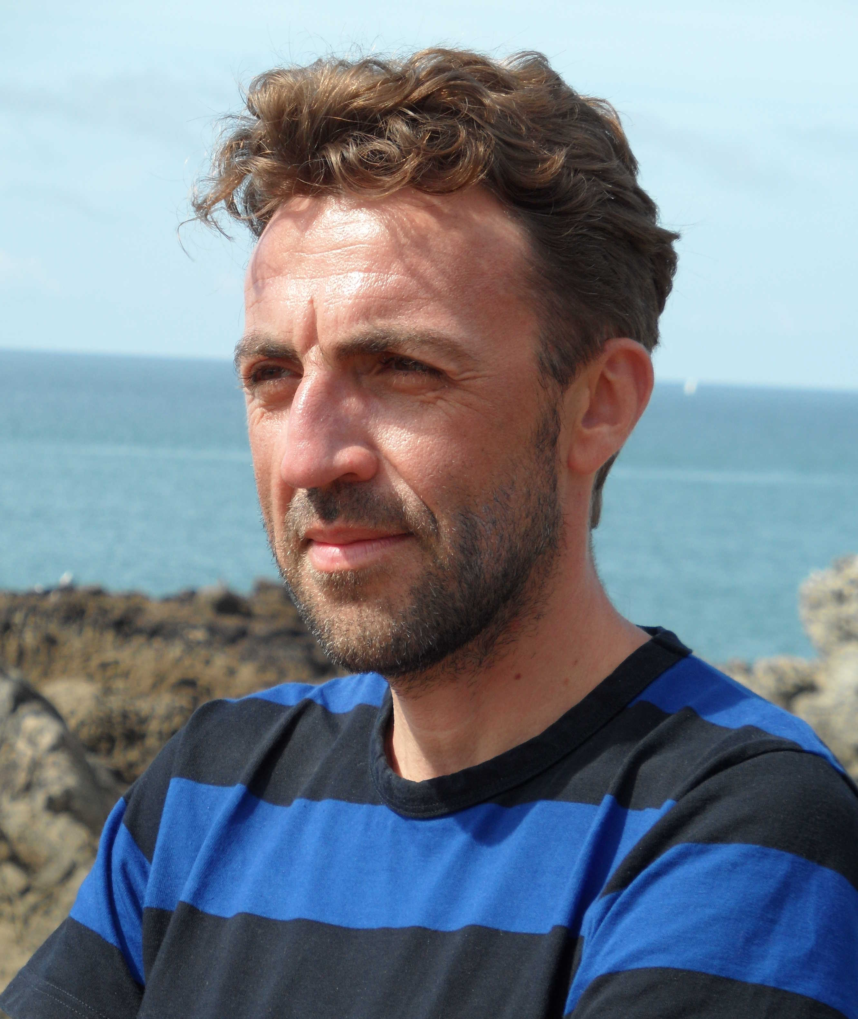

***Equilibrium Simulations of Supercooled Liquids Beyond Laboratory Timescales***

Professor Ludovic Berthier

Laboratoire Charles Coulomb

University of Montpellier

Hosts: Professor Mark Ediger

Computer simulations give unique insights into the microscopic behavior of disordered and amorphous materials, but their typical timescales are orders of magnitude shorter than the experimentally relevant ones. In particular, simulations of supercooled liquids performed with standard techniques cover at most 4-5 decades of viscous slowing down, far behind the 13 decades commonly accessible in experimental studies. Recently, we have closed this enormous gap for a class of realistic models of liquids, which we can successfully equilibrate beyond laboratory time scales by means of a swap Monte Carlo algorithm. For some models, we achieve over 10 orders of magnitude speedup in equilibration timescale. This exciting numerical advance allows us to address some outstanding questions concerning the formation and properties of glasses in a dynamical range that remains inaccessible in experiments, such as the relevance of an entropy crisis, the kinetics of ultrastable glasses, and the rheology of realistic glassy materials.

Sponsored in part by:

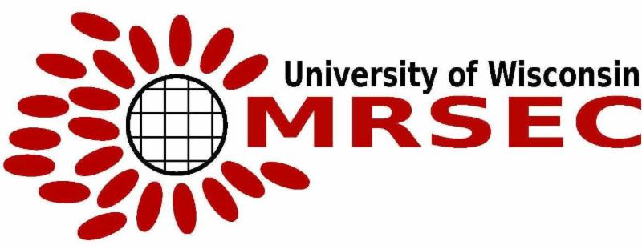

Refreshments will be available prior to seminar at 10:45 a.m. in the Shain Atrium

Graduate Students can meet with the speaker in Room 8305F at 1:00 pm