Molecular Electrocatalysis and Materials Reactivity
from a Proton-Coupled Electron Transfer Perspective

Proton-coupled electron transfer (PCET) is central to a wide range of chemical and biochemical processes. After introducing PCET and some of its fundamental principles, this presentation will apply these fundamentals to challenges in electrocatalysis and materials. Soluble iron porphyrin complexes have been examined as electrocatalysts for the oxygen reduction reaction, O₂ + 4e– + 4H⁺ → 2H₂O. The results are examined in light of a new approach to examining the relationship between catalytic turnover frequency (TOF) and electrochemical overpotentials (Left Figure below). This approach provides ways to understand the different components of an electrocatalytic system, to compare different systems, and perhaps to predict improved catalysis. The last section will describe some of the PCET chemistry of colloidal ZnO, TiO₂, and CeO_{2-x} nanocrystals that we are developing. For instance, reduced ZnO nanocrystals transfer of e– and H⁺ (H•) from reduced ZnO to the nitroxyl TEMPO (Right Figure below).³ Such reactivity is prompting new perspectives on interfacial reactivity at the nanoscale.

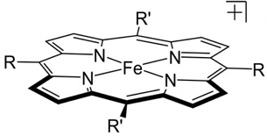
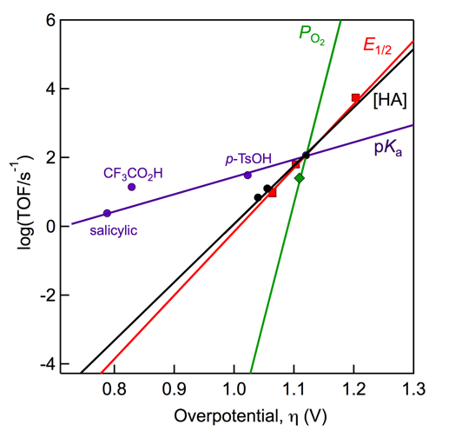
ZnO:e–,H⁺

Professor James Mayer
Yale University

Wednesday, October 17, 2018
3:30pm in room 1315 Chemistry

If you wish more information please call 262-6815
Refreshments will be available at 3:15 pm outside of Seminar Hall

