Prof. Kenneth Caulton

Indiana University

“Spin States, Unsaturation, and Pi-Donation:Impact on Reactivity?”
A challenge for chemistry today is to make chemical reactivity of transition metal complexes as systematic and rational as that of organic chemistry. It will be argued that the amide ligand (^{t}Bu₂PCH₂SiMe₂)₂N⁻¹, “PNP” creates a sterically protected (from ^{t}Bu) and electron rich (from amide N pi-donation) metal center with unusual reactivity. When it is attached to Ru(II), the compound (PNP)RuCl is unusual in being “doubly unsaturated,” 4 coordinate and planar, and this leads to facile binding of PhCN, C₂H₄, and N₂, but remarkably “deeper” reactions with H₂, with terminal alkynes, and with Me₃SiN₃. The analogous osmium chemistry shows dramatic differences, leading into the chemistry of radical species, and the rhodium analog shows remarkable C-H bond cleavage ability. Understanding all of this reaction chemistry is enhanced by concurrent DFT calculations, which reveal levels of ligand redox non-innocence. Generalization of the above reactivity principles is possible by studies with lighter transition elements Fe, Co and Ni, which, in turn, leads to results relevant to the concept of a chemical reaction being “spin forbidden.”

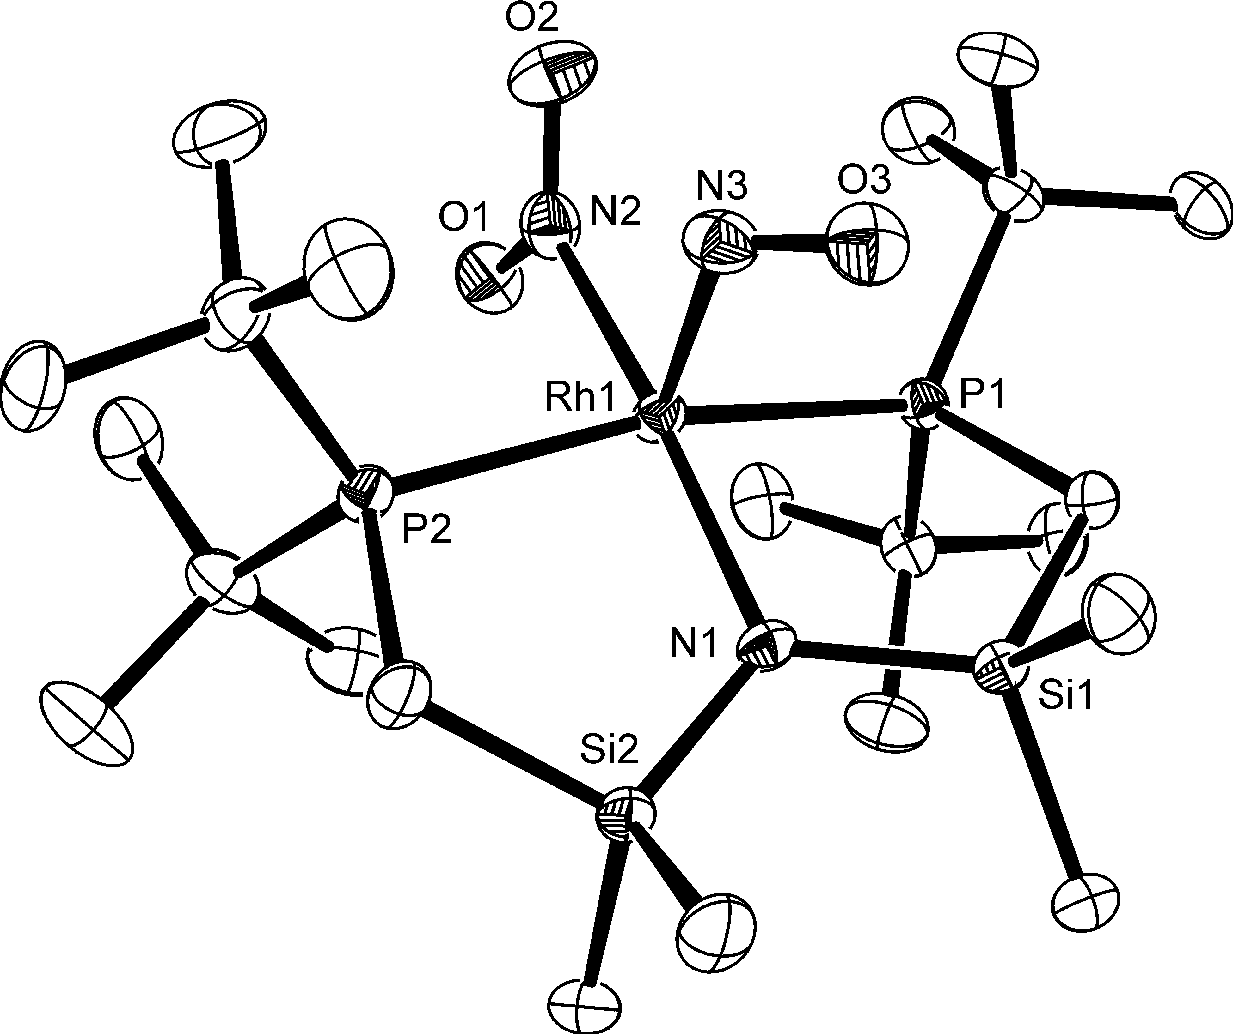

Wednesday, February 3rd, 2010
3:30 P.M. ROOM 1315 CHEMISTRY

FOR MORE INFORMATION PLEASE CALL THE INORGANIC OFFICE AT 262-6815
Host is John Berry
Refreshments will be available at 3:15 outside of the seminar room, and setup by Elizabeth Blaesi. Thanks Elizabeth.

