Update to the Fall 2000 Lab Manual

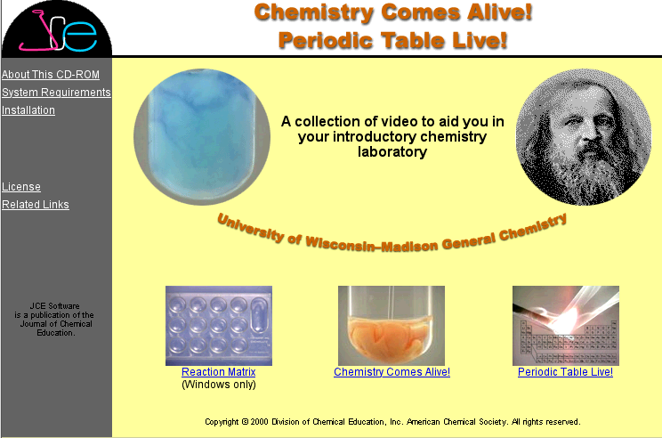

After the manual went to press, the nice people at Journal of Chemical Education Software decided to create a gateway page for the custom CD they were making for us. This gateway page, called “Start(NN).html” (for use with Netscape Navigator) or “Start(IE).html (for use with Internet Explorer) is reproduced above. On page 13 of the lab manual, in section A of the Data Collection, where the manual tells you to double click the “Index” icon, you should instead double click the appropriate “Start” icon for your preferred browser.

Once the page above is displayed, click the link entitled “Chemistry Comes Alive!” to perform Part A of the “Reaction Types and Chemical Logic” Exercise. This part will work on any computer with Quicktime™ installed.

To perform Part B of the exercise, you will need to use a computer running Microsoft Windows and click the “Reaction Matrix” link. This part of the exercise uses a java program which is not cross platform and was written for Netscape Navigator. If you have problems running the program in Internet Explorer, you should use Navigator instead. The General Chemistry Computer room (1327) has computers which are suitably equipped if the computer you use routinely does not meet these specifications.

The software for the Periodic Table Live! exercise (page 49) which you will do later in the semester is also accessed from the above gateway page.

